Sound & Lighting Technical Info

Power required:
- 8 power sockets at stage rear (4 left side & 4 right side).
- 4 power sockets at stage front (centre).

In-EAR Monitor Mixes required:
Drummer – Flat mix with slight boost on the bass.
Lead guitarist – Flat mix with slight boost on lead guitar.
Frontman/Rhythm Guitar – Flat mix, slight boost on centre lead vocal.

Stage Wedge Monitor Mixes required:
Bassist – Bass guitar, Both backing vox

**As per the stage layout diagram (page 3) it would be preferable to also have the other 3 monitor wedges on stage, ‘ready-to-be-switched-to’ in case of in-ear sound failure.

Frontman Acoustic DI:
Frontman uses an electro acoustic guitar – his DI box is already connected already on his pedalboard, so just needs a ‘passive’ XLR connection from there to the desk.
Finally, if you hear the acoustic sound drop off on the desk during a song, don’t panic - as frontman will have probably switched the signal to go through his amp for some added distortion during some songs.
Continued overleaf…..
Intro Track:
Green Haze will provide an MP3 player that contains the intro track to begin the show. We will show you which track to play on the night.
This track needs to be started x minutes before the show begins (where x is the length of the intro track).
The tracks are designed to be started and can then be left to just finish automatically – upon where the band are on stage by then.
Please crank the volume of intro track up (i.e louder than background/filler music) as it’s part of the show and should be show volume.
** Please return the MP3 player to a member of the band at the end of the night. Thank you. **

Lighting (only applies to indoor venues or outdoor stages at night):
The stage walk-on is during the ‘2001 - A Space Odyssey’ intro music. Band take positions ¾ of the way through as the intro music progresses.
Please ensure stage is blacked out during the first part of the intro, except to provide required lighting to enable a safe walk on.
Then, stage lights up as the crescendo kicks in – i.e. as band enters the stage.
** Please do ensure enough stage lighting is on/up when band enters the stage, to avoid accidents and so we can find our positions, guitars etc. Thanks!

Please turn over for Stage Layout…

Stage Layout:

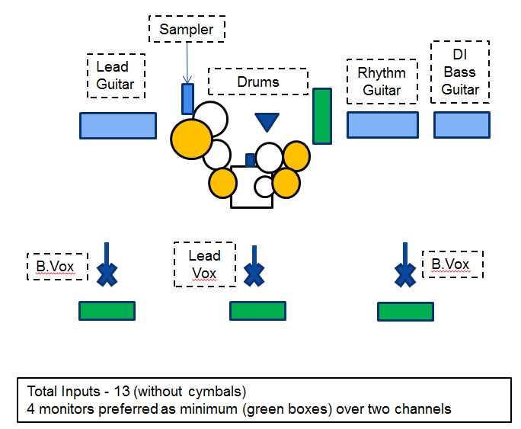

Please turn over for Input/Channel list for the desk…

Full Input/Channel list including all required inputs to the desk:

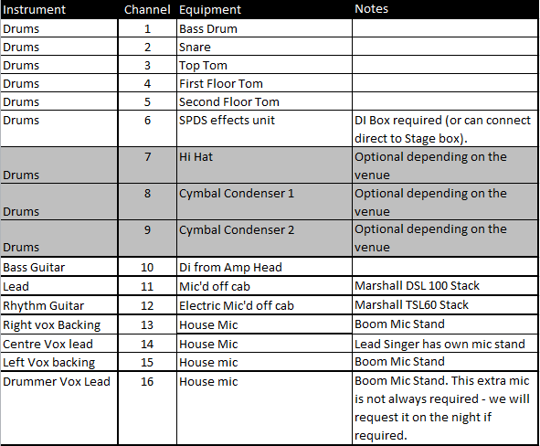

* Please note – NO rim-clip microphones to be used for the snare drum. All other drums are OK for rim-clip mics. Thank You.

